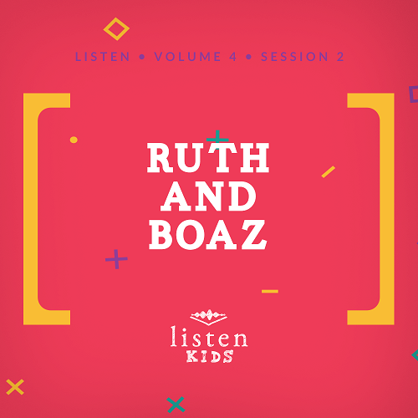
Leader Overview
Our God holds everything in His hands. He knows the past, the present, and the future. He also cares about each person as an individual. That means every boy, girl, man, and woman. They are all part of His plan for this world. If we are faithful to live our lives for Him and do what He asks us to, then we will find out that He works everything for the good of those who love Him!

Bible Lesson
Marriage of Ruth and Boaz
Ruth 4:13–22
Faith Fact
God provides for me.
Faith Verse
Isaiah 41:10 (NLT)
“Don’t be afraid, for I am with you. Don’t be discouraged, for I am your God. I will strengthen you and help you. I will hold you up with my victorious right hand.”

Preparing for the Session
Leader Preparation Time: 20–25 Minutes
You Will Need
Large Group
- Bible
- Worship songs (Song suggestions: “Real Love” by Hillsong Young & Free; “Chain Reaction” by River Valley Worship; “Good Good Father” by Chris Tomlin)
- For groups not using a phone or tablet only, add:
• Projector or TV
• Laptop
• Countdown60 Video–60 seconds
• Rules Video or Slide
• Faith Fact Slide
• Faith Verse Video or Slide
• Bible Lesson Slides 1–2
• Bible Lesson Slide 3 with Audio
• Bible Lesson Video A
• Bible Lesson Video B
• Playpen balls or puff balls
• 4 large buckets
Small Group
- Small Group Activity Page, one per kid
- Small Group Group Connection page
- Small Group Faith Verse Review
- Basket, any size
- Pencils
- Jars, one per group
- Raw rice

To download session videos, slides, and printables, visit: BibleEngagementProject.com/downloads

Getting Ready
Large Group
- Download videos and slides if needed.
- Select worship song(s) and have them ready to play.
Small Group
- Print copies of the Small Group Activity Page, one per kid.
- Print the Small Group Group Connection page on colored paper, one color per group.
- Print the Faith Verse Review page.
- Cut out the Faith Verse into different sections.
- Pour rice into each jar.
- Tightly roll the sections of the Faith Verse and drop into the jars of rice.

First time leading Listen for Kids? Check out the Facilitator Guide.
Large Group
30 Minutes
See what’s needed at the beginning of the session.

Introduction
Hey kids! It’s so great to have you here! Have you ever been sad or disappointed? Has anything ever gone wrong for you? Well, I’m sure the answer to that question is yes. Every person has been sad or disappointed at some point. We know that because sin entered the world there is sickness, sadness, and even death. We also know that God has a plan to provide for all His children. When something doesn’t go the way we thought it would, we can go to God. When we turn to Him, we see that He provides for us, sometimes in ways we could never imagine.
Today, we’re going to hear about someone who had something really sad happen to her. She could have blamed God or had a bad attitude, but she didn’t. Instead, she decided to turn to God to provide for her. It wasn’t always easy, but because of her faithfulness to God, she and her family were provided for. And you know what, that’s our Faith Fact for today: God provides for me.
• Show the Faith Fact Slide.
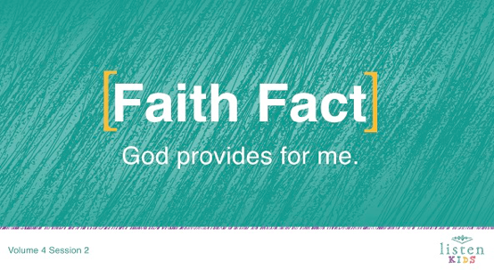
Say it with me on the count of the three. 1, 2, 3. God provides for me. One more time! God provides for me. Great job!
Rules Review (Optional)
Who wants to have fun today? (Group response) I want to have fun, too. Before we get started, we need to make sure that we all know the rules. Let’s watch a short video now.
• Play Rules Video.

Game
Before we move to the Bible story, who wants to play a game?
We’re going to form four evenly sized groups. We’ll have a timer for one minute. When I say, “Go,” each team will collect as many balls as you can and return them to their bucket. They must be in the bucket before time runs out. The team with the most balls inside the bucket wins.
• Form groups by having kids count off 1–4 until everyone has been assigned to a group.
• Have each group go to their own area.
• Give each group a large bucket.
• Scatter the balls around the room.
Is everyone ready to play? On your mark, get set, go!
• Play the Countdown60 Video–60 seconds.
• When time runs out, count the balls to determine the winning team.
• Repeat as time allows.
This game reminds me of a woman in today’s Bible lesson, Ruth. Just as we ran around and collected balls off the ground, she spent her days in the fields collecting leftover grain on the ground. It was hard work, but she was happy to do it because it provided food for her and her mother-in-law. We will hear more about that in a bit.

Worship
Now it’s time to praise Jesus! Are you ready? Get on your feet. Here we go.
• Lead the kids in singing one or two praise songs. See suggestions at the beginning of the session.

Bible Lesson
Have you ever wondered how you’re going to do all that God asks of you? I know I have. And I know the best place to look to find the answer. Do you know what it is? (Group response) It’s in God’s Word, the Bible. (Hold up your Bible.) Before we get started in God’s Word, let’s take a moment and pray and invite God to be with us.
Prayer
Dear God, thank You for being with us and believing in us. Help us to know You more as we learn from the Bible. Amen.
Video Intro
Before we get started learning more from God’s Word, the Bible, let’s check in with our Challenge Accepted friends, Dash and Austin, and see what they’re up to!
• Play Bible Lesson Video A.
Wow! Would you like to accept that challenge? (Group response) I’m not sure that I would want to stack bread on my head. But that’s a great lead-in to our Bible story.
Bible Story
(Open the Bible to Ruth.) Today’s Bible reading starts off with something that no one ever wants to face—a famine! That means there is little or no food. Uh-oh! No chips! No pizza! No tacos! Let’s read Ruth 1:1.
• Read Ruth 1:1.
What do you think that meant for people? They had to find a way to eat. The Bible book is named Ruth, but our story actually begins with a man named Elimelech. He was Ruth’s father-in-law. Before we get to what happened to him, tell your neighbor what your favorite food is! (Let kids pair share.)
There was no food in Bethlehem, which is where Elimelech and his family lived, so they had to leave the city. Elimelech’s wife was named Naomi, and they had two sons, named Mahlon and Kilion. They all moved to a country called Moab.
• Show the Bible Lesson Slide 1.
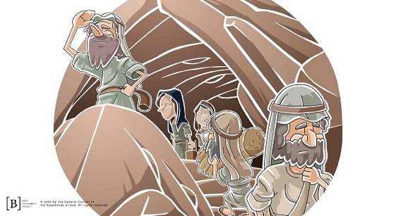
Have you ever moved before? (Group response) That’s not easy. Then, something very sad happened: Elimelech died. Naomi was left with her two sons. Well, Mahlon and Kilion married two women from Moab. Their names were Orpah and Ruth. Say Orpah ten times fast! (Allow responses.)
You know what? Another sad thing happened. About ten years later, both Mahlon and Kilion died. Now, Naomi, Orpah, and Ruth were all widows—women whose husbands have died. What were they going to do? In those days, men were usually the ones to take care of their families by working. Now that their husbands were dead, what was going to happen to Naomi, Orpah, and Ruth? (Allow responses.)
Naomi heard that the famine was over in Bethlehem and decided she was going to move back home. They all packed up and headed off. On the way, Naomi told Orpah and Ruth that they should go back to their family homes instead of going with her to Bethlehem. She thanked them for being so kind, but said they would be happier in Moab.
They all cried together, and both Orpah and Ruth told Naomi they wanted to go with her. Naomi insisted they return to their families in Moab. So, one of them did go back, but one stayed. Who do you think stayed? (Group response)
Let’s read Ruth 1:16 to find out which of the daughters-in-law stayed.
• Read Ruth 1:16.
Ruth returned to Bethlehem with Naomi. They arrived just in time for the barley harvest. That’s the time of year when people collect the crops they have planted and have been taking care of for months.
Ruth decided she was going to go out into the fields and pick up the stalks of grain left behind by the people who were harvesting. So, she went to a field and began gathering the dropped grain.
• Show Bible Lesson Slide 2. (Ruth in Field)
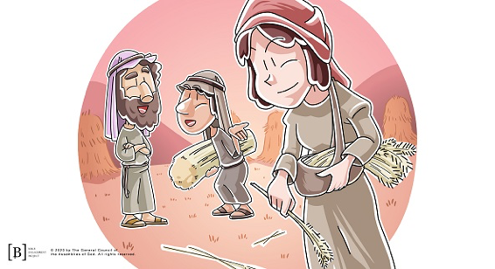
While she was there, a very important man noticed her. His name was Boaz. Why was he important? Well, he owned the field. When he saw Ruth and heard that she was taking care of Naomi, he told her to stay in his field and work right behind the other women who were harvesting.
Boaz said she could get a drink of water from his well anytime she was thirsty. Let’s read Ruth 2:10–12 to see what Boaz said to Ruth.
• Read Ruth 2:10–12.
Boaz recognized how faithful Ruth was to Naomi and wanted to take care of her. He even told his workers to drop some of their grain on purpose so Ruth could pick it up! God provided for Ruth and Naomi through Boaz’s generosity.
When Ruth got home and Naomi saw all the grain she had collected, she was so happy. Ruth told Naomi about Boaz, the kind man who had helped her. Naomi was even happier when she found this out because Boaz was a relative of her husband, Elimelech, and one of their family redeemers.
You see, one of the Israelite laws said that a special family member should step in and help if something really bad happened in the family. That special person would be called the family redeemer. Boaz was one of the men in Naomi and Ruth’s family who could step in and help them out. So, Naomi told Ruth to keep working in Boaz’s fields through the end of harvest.
Naomi had an idea. She told Ruth to dress up in her nicest clothes and go to Boaz that night. The plan was for Boaz to help the family by marrying Ruth. After Boaz had eaten dinner that night, he went to sleep. Ruth went to the place he was sleeping and laid down by his feet. In the middle of the night, Boaz woke up. When he saw Ruth laying at his feet, he asked, “Who are you?” Ruth told him that she was there and that he was their family redeemer.
Boaz figured out that Ruth wanted to marry him. So he told her that she was showing great loyalty to their family. He said he would marry her. He just needed to make arrangements the next day. So, he gave Ruth six scoops of barley and sent her home to Naomi. When Ruth got home, she told Naomi all that Boaz had done.
The next day Boaz made all of the arrangements necessary, and soon he and Ruth were married!
• Play Bible Lesson Slide 3 with Audio.
Later, Boaz and Ruth had a baby boy, and they named him Obed. Naomi was a grandmother, and her heart was filled with joy once again! God was faithful to provide all that Ruth and Naomi needed.
Teaching Time
You know, sometimes things don’t go the way we planned, do they? In those times, we have a choice. Some people choose to turn away from God and face things on their own. That only leads to more pain and sadness. Others turn toward God and allow Him to bring something good out of what looks like a bad situation.
Ruth was in that second group of people. She was faithful to God and her family in a hard time. Because of that, God greatly blessed her. She married Boaz and had a son, Obed. Even when things looked hopeless for Ruth and Naomi, God provided for all of their needs.
God isn’t mentioned much in the whole story of Ruth and Naomi, but God was always working to make sure that their needs were met. He led them, and He provided for them. In the same way, God is working in the background of our lives to make sure our needs are met, even when we don’t see Him working.
Want to know something else that’s cool? Obed was the father of Jesse, and Jesse was the father of another famous person in the Bible. Guess who? (Allow responses.) David! And, do you know who was a descendant of David? (Allow responses.) Jesus! That means Jesus was a descendant of Boaz and Ruth. How amazing is that? The One who would redeem us all was related to the family redeemer of Ruth and Naomi!
Faith Verse
Let’s say our Faith Verse together:
• Play Faith Verse Video.
Isaiah 41:10 (NLT)
“Don’t be afraid, for I am with you. Don’t be discouraged, for I am your God. I will strengthen you and help you. I will hold you up with my victorious right hand.”
What will you choose to do in hard times? Or in times when you don’t feel like you have enough? There is Someone you can turn to. God will give you what you need to make it through and even more. He knows you. He loves you. And He wants you to turn to Him even in the hardest times. He is close. You can say, God is my provider.

Prayer and Response
Consider playing a worship song softly in the background while kids pray.
Let’s take some time to worship and thank God. He provided for Ruth and Naomi, and He does the same for you and me, too. He provides food, shelter, family, friends, clothes, and so much more. Join me for a few moments in praising and thanking God for all He is and all He has done.
• Give kids time to pray. Then introduce the worship song. This could play in the background while kids pray or could be a worship song to sing together.
Worship Song
Play a worship song. See suggestions at the beginning of the session.
Video Wrap-Up
Before we go to our small group activities, let’s see how Dash and Austin’s challenge worked out.
• Play Bible Lesson Video B.

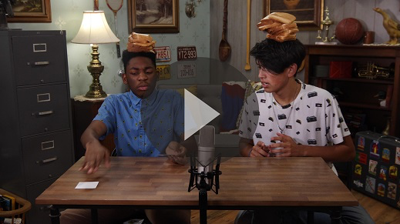

Let’s all accept the challenge that Dash gave us. Remembering things that God has provided for us will show us that God is with us. And don’t forget the Faith Fact for today.
• Show the Faith Fact Slide.
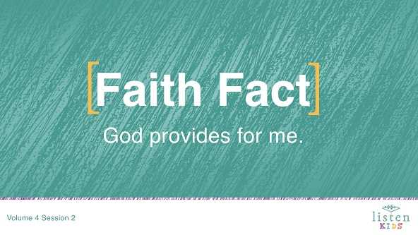
Say it with me. God provides for me. Thanks for a great time learning about God together.
• Dismiss kids to Small Group time or to go home if your group time ends here.

Small Group
30 Minutes
This section can be done in conjunction with the large group, or on its own if you do small groups with your kids. During Small Group time, the goal is to connect the kids with the Word of God and to each other. All activities are led by the small group leader.

Group Connection
Sheaves Hide and Seek
You Will Need
- Small Group Group Connection page
- Countdown60 Video–60 seconds
Getting Ready
- Print the Small Group Group Connection page on different colored paper, one color per team. (Note: The number printed will be determined by the number of kids in the groups.)
- Cut apart the sheaves.
- Hide the sheaves in the room for the kids to find. (Save one for an example.)

Okay, kids! I have hidden sheaves all around this room. Do you know what sheaves are? (Group response) That’s the name of a bundle of grain. It’s what Ruth spent all day gathering! Each group has a different color for their sheaves. You will have one minute to find all of your colored sheaves. Be sure to only gather your color!
• Divide the group into at least two teams.
• Play the Countdown60 Video–60 seconds.

Bible Lesson Recap
You Will Need
- Bible, one per kid

No prep needed for this activity.

Bible Story Review: Ruth 4:13–22
Ruth had something really sad happen to her. She could have blamed God or had a bad attitude, but she didn’t. Instead, she decided to turn to God to provide for her. It wasn’t always easy, but because she was faithful to God, Ruth and her family were provided for!
• Divide the Bible reading into smaller chunks for volunteers to read aloud.
Faith Fact
God provided food, a home, and a husband for Ruth. It was just what she needed! God knows what we need and provides for us, too!
• Show the Faith Fact Slide.
Point to yourself and say our Faith Fact with me: God provides for me.

Group Discussion
Feel free to use all or just a few questions as a jumping-off place for good discussion. Questions marked with * are designed for more conversation. Adjust the questions based on the age or maturity of your group. Typically, older children will be able to dive a little deeper than younger ones.
Questions
What was the name of Ruth’s mother-in-law?
What country was Ruth from?
In whose fields did Ruth glean?
What was the name of the role and responsibility that Boaz had that meant he had to care for Ruth and Naomi?
How did God reward Ruth?
* What are some ways that God has provided for you and your family?
* Why can we trust God to provide for our needs?
* What are some ways God can use us, like He used Boaz, to help provide for other people’s needs?
* Why do you think God chose to send Jesus as one of Boaz and Ruth’s descendants?

Application and Response
Being a faithful follower of God isn’t easy. In fact, sometimes the things God asks us to do are hard or not much fun at all. In those times, we have a choice. We can go our own way, or we can go God’s way. When we choose to do it God’s way, we are being faithful. God always rewards faithfulness. What do we do if we think God’s way is too hard? We ask God for help! He may not make the task any easier, but He will help to strengthen and encourage us to complete it. He always provides.
Make It a Habit
Select a simple visual reminder of the session’s Faith Fact.
You Will Need
- Basket

No prep is needed for this activity.

We need to make it a habit to remember what we’ve learned about God today. Every time you see a basket, I want you to remember that God provided for Ruth and that God will provide for you, too!
• Show the kids a basket. It can be any size.

Prayer
Let’s pray and ask God to help us.
Thank You, God, that You are always faithful and will always provide for us. We are grateful that You always provide just what we need. We love You. Amen.

Faith Verse Review
You Will Need
- Faith Verse Review page, one per group
- Jars, one per group
- Raw rice
Getting Ready
- Print the Faith Verse Review page, one per group.
- Cut apart the Faith Verse into different sections.
- Put rice in each jar.
- Tightly roll the sections and drop into the jars of rice.

Our Faith Verse for today tells us that we don’t need to be afraid or discouraged because God is with us and will help us. When we know God’s Word, He can bring a verse or Bible story to mind just when we need it.
• Show the Faith Verse Slide.
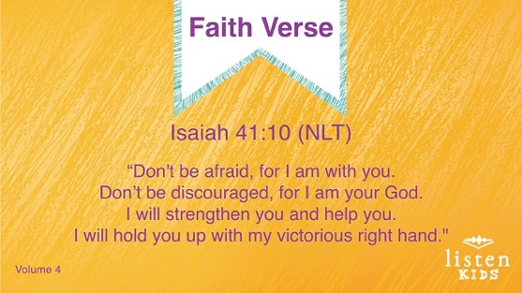
Let’s say it together with the actions.
Isaiah 41:10 (NLT).
“Don’t be afraid, for I am with you. Don’t be discouraged, for I am your God. I will strengthen you and help you. I will hold you up with my victorious right hand.”
Let’s lock this verse in our hearts and minds so that we always remember it!
• Repeat the verse several times. Get creative with the verse practice. Split the group up and have them compete. Try saying it in different voices or pitches. Ask individual kids to choose how to practice it. Have fun!
Faith Verse Fun
Feel and Find
Kids, I have a challenge for you. Just like Ruth searched for food in the fields, you are going to search for the Faith Verse. This jar is filled with rice and mixed in are little pieces of paper with part of our Faith Verse on it. Each of you is going to have a turn to reach in and find one of those papers.
When you have found all the papers, your group will put them all in order to spell out the Faith Verse. When you have the verse in order, your group must read the verse together out loud. Are you ready to play?
• Form groups that will work together to put the Faith Verse in order.
• Taking turns, kids will reach into the jar of rice to find a piece of paper with part of the Faith Verse on it.
• When all the pieces of paper are found, the group works together to put the Faith Verse in order.
Ruth and Naomi came to Bethlehem in search of help after their husbands had died. They needed food and someone to take care of them. They chose to trust God to provide for them and He did! In our Faith Verse, God reminds us that we don’t have to be afraid when we are in need or discouraged when things don’t go our way because He is with us. We can count on God to help.

Creative Activity
Crossword Puzzle
You Will Need
- Small Group Activity Page, one per kid
- Pencils
Getting Ready
- Print the Small Group Activity Page, one per kid.

This crossword puzzle is based on the Bible story that we heard about today. Check out the clues and see if you can complete the puzzle.
Life can be like a crossword puzzle, full of questions. Some questions are harder than others. And sometimes, we don’t know the answer. When you are unsure of what the right answer is, you can pray and ask God. He has promised to always provide help!

Crossword Answer Guide
Down: | Across:
1. Family | 3. Boaz
2. Naomi | 5. Famine
4. Bethlehem | 6. Provides
5. Field

7. Ruth

Prayer
Dear God, thank You so much for showing me in the Bible how You provide for Your people. Thank You for providing for me. Help me to trust You. Amen.

Faith Fact Recap
• Display the Faith Fact Slide as parents are coming into the room.
• Maximize the time you have with your kids so that parents see what their kids have learned. Have the kids repeat the Faith Fact, and then dismiss them to their parents.
Let’s all remember our Faith Fact from today.
• Show the Faith Fact Slide.
Say it with me: God provides for me. That was great! See you next time!

Dismissal
• Send home the Small Group Activity Page with each kid.
• Remind parents that there are Family Devotions available on the app to do with their kid.
• Tell everyone the date and time for the next session.

